Software Requirements Specification

For

Mobile App  
Food Trip Search Engine

Version 1.0 Approved

Prepared by:

Jimmy Tan

Rouzandra Zuniga

Jason Juarez

10/21/15

Table of Contents..........................................................................................................ii-iii

Revision History ..............................................................................................................iii

1. Introduction .................................................................................................................4

1.1 Purpose ....................................................................................................................4

1.2 Document Conventions ........................................................................................... 4

1.3 Intended Audience and Reading Suggestions .........................................................4

1.4 Product Scope ......................................................................................................... 4

1.5 References............................................................................................................... 4

2. Overall Description .....................................................................................................5

2.1 Product Perspective .................................................................................................5

2.2 Product Functions .................................................................................................... 5

2.3 User Classes and Characteristics ............................................................................ 6

2.4 Operating Environment............................................................................................. 6

2.5 Design and Implementation Constraints ...................................................................7

2.6 User Documentation ................................................................................................. 7

2.7 Assumptions and Dependencies .............................................................................. 7

3. External Interface Requirements .................................................................................8

3.1 User Interfaces..................................................................................................... ….8

3.2 Hardware Interfaces .................................................................................................10

3.3 Software Interfaces ..................................................................................................11

3.4 Communications Interfaces ......................................................................................12

4. System Features ........................................................................................................12

4.1 System Feature 1 .....................................................................................................12

4.2 System Feature 2 (and so on)...................................................................................13

5. Other Nonfunctional Requirements ............................................................................13

5.1 Performance Requirements ......................................................................................13

5.2 Safety Requirements ................................................................................................14

5.3 Security Requirements .............................................................................................14

5.4 Software Quality Attributes .......................................................................................14

5.5 Business Rules .........................................................................................................14

6. Other Requirements ...................................................................................................14

Appendix A: Glossary......................................................................................................14

Appendix B: Analysis Models .........................................................................................14

Appendix C: To Be Determined List ...............................................................................14

Revision History

|  |  |  |  |
| --- | --- | --- | --- |
| **Name** | **Date** | **Reason For Changes** | **Version** |
|  |  |  |  |
|  |  |  |  |

**1. Introduction**

FoodTrip Restaurant Search Engine is an Application where you can easily access restaurant around Metro Manila explore high class restaurant's in different cuisine category and choose a restaurant you want to visit where you can view information, feedback and promotion deals.

**1.1 Purpose**

The purpose of this document is to present a detailed description of the FoodTrip Search Engine Mobile App. It will explain the purpose and features of the system, the interfaces of the system, what the system will do, the constraints under which it must operate. This document is intended for both the stakeholders and the developers of the system.

**1.2 Document conventions**

Not applicable

**1.3 Intended Audience and Reading Suggestions**

This document is intended to be read by the Owner of the restaurant, Documentation Head, Operation Head and the Programmers only, Stated on the document are some of the features and details about the project. This is where they can understand the value or the main concept being implied by the system.

**1.4 Product Scope**

The Major features in the application is GPS location shows your location, including latitude & longitude and the restaurant you want to visit. Direct Call to restaurant' you can simply make a call by pressing the call tab of the restaurant.

**1.5 References**

**2. Overall Description**

**2.1 Product Perspective**

We come up to decide to think about what idea's or plans we should be doing for our application we estimate time and cost for the features and platforms we'll be needing for this app to develop navigation we concentrate on the core features we create a data model which organizes all the information in our search engine app we create navigation using tab bar and menu's.

**2.2 Product Functions**

Major Features

• GPS location      
• Food Ratings     
• Direct Call to restaurant's     
• Restaurant Updates

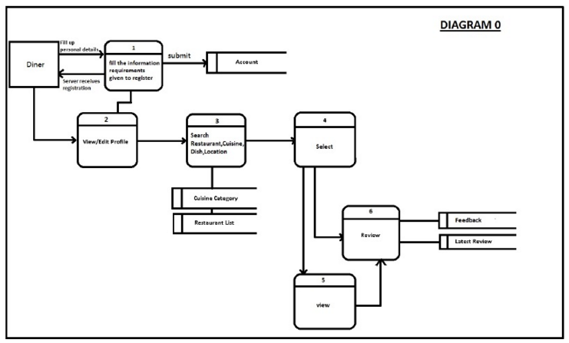

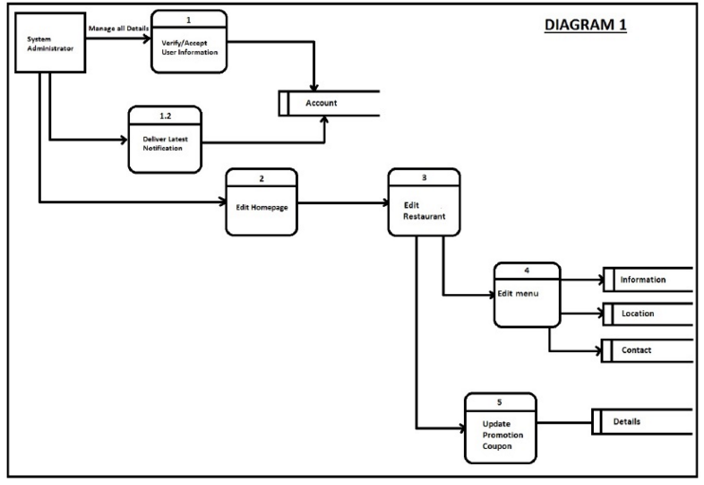

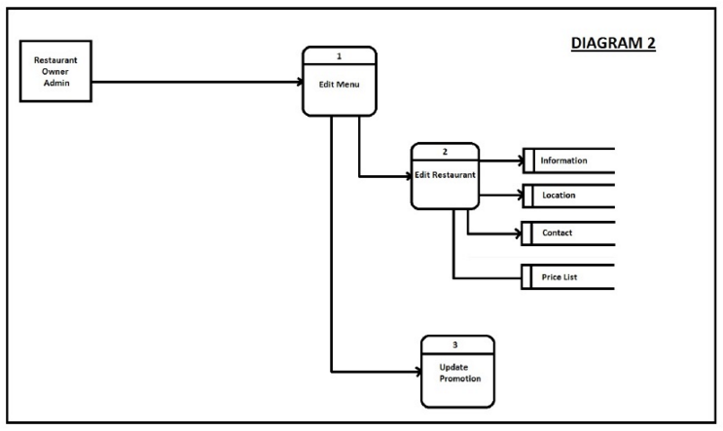

2.3 User Classes and Characteristics

2.4 Operating Environment

**Hardware Environment**

The focus of this project is to apply the use of android phones and the internet for the user for better information about different cuisine and restaurant around metro manila. Hardware

Smartphone that has at least 512mb of ram, android version 4.2 (Jelly Bean)

### Software Environment

### Programming Language

### The application will be developed using HTML5, PHP, CSS, JS and lQuery Mobile framework

### Specific Software

### FoodTrip application uses the SQLite Database to store data and is connected to cloud server

### Operating System

### The application runs in Android Operating System. Android API level 19 kitkat

### Network Requirements

### Internet connection – specifically DSL or Boradband internet or wifi connections

### 2.5 Design and Implementation Constraints

### 2.6 User Documentations

### 2.7 Assumptions and Dependencies

When the project begins, there is assumptions and constraints project member’s availability, project member’s performance, project member’s skills Budget limitations, Internal process lead time, internet issues, device problems and Accuracy of the project schedule dates.

 Limitations

Ordering function is not included in the application we are developing. Only the members can receive notification of the restaurant updates, promotion updates, Scan QR Code to avail the promotions.

### 3. External Interface Requirements

### Overview

The user interface of this restaurant booking system is a web site which can be viewed using popular web browsers. This high accessibility made it easier and more convenient for users to use the system. Users don't need to set up any additional software for the purpose of running the system. As long as an Internet connection is available, the system can be easily accessed using their mobile devices. Multi-platforms operation is also an additional advantage of this design.

One more advantage of this design is the power of the Hyper Text Markup Language (HTML). HTML provides nicer features with simple modification and configuration compared to the GUI of other languages. HTML language supports the use of other languages and technique to make dynamic objects, which can improve the vividness of the application.

### 3.1 User Interfaces

These are the fundamental features of the GUI that should be included in the websites:

### A login box comprises of an account and a password text field. Users can sign in using their Facebook account to become a member. We can provide the sign up function for long-term users so that they don't have to refill the information every time they visit the website.

A dynamic menu including the links to the homepage, the Food Categories, the Favorites, features, map, search button, and the Galleries.

The Category page will have the list of different restaurant with its respective image and ratings. It can be divided into many pages to ease up the navigation. The favorite page display the user restaurant marked as their favorite and a clickable map for the reservation of seats. The information page will provide additional information about the restaurant.

A slideshow or a flash of the images of the restaurant.

### 3.2 Hardware Interfaces

Describe how the software application interfaces with hardware that exists outside the scope of the system.

### 3.3 Software Interfaces

### 3.4 Communication Interfaces

### 4. System Features

### 5. Non-functional Requirements

**Non-functional requirements**

There are requirements that are not functional in nature. Specifically, these are the constraints the system must work within.

**5.1 Compatibility**

* + 1. The website should be compatible with both Internet Explorer and Mozilla Firefox, Google Chrome and Android and Smart phones.

**5.2 User interface**

* + 1. The user interface should be as familiar as possible to users who have used other web applications and Windows desktop applications. E.g., we will follow the UI guidelines for naming menus, buttons, and dialog boxes whenever possible.

**5.3 Security**

* + 1. Access will be controlled with usernames and passwords
    2. Only administrator users will have access to administrative functions, average users will not.
    3. Database should be reasonably secured to prevent leak or loss of confidential information such as credit card details from customers.

**5.4 Performance**

* + 1. The system should be up and running 24/7.
    2. It should support at least 100 users using the online without any lag.

**5.5 Backup and Recovery**

* + 1. There should be a backup server and database to prevent service interruption or loss of data when the main server and database are down.
    2. Downtime should not last more than 30sec when switching from main server to the backup server in case of a breakdown.

**5.6 Reliability**

* + 1. The Restaurant menus and price must be updated.
    2. The location of the restaurant must be accurate for the reference of the user/diner
    3. System review will take place monthly. Any lack in performance or reliability will be addressed and improved on after each review.

**5.7 System Maintenance**

* + 1. Maintenance of the system will be conducted weekly. Maintenance will be conducted during off-peak hours e.g between 12am - 6amz